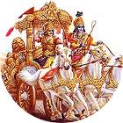
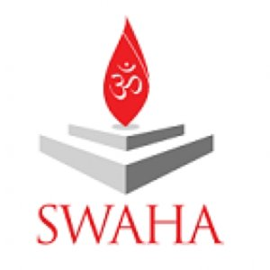
REGISTRATION FORM
IGF Saturday 06th December, 2014 10:00 am – 3:00 pm
Name First and Middle ________________________________ Last Name ____________________
Mailing Address: _______________________________________________________________
Gender (please tick the appropriate box): [] Female [] Male
Telephone: _____________________________ Email: ________________________________________
Organization affiliation if any: ____________________________________________________________
Level of Participation in The Forum (please tick the appropriate box): [] Personal [] Organizational

Knowledge of The Srimad Bhagwad Gita (please tick the appropriate box)
[] Introductory [] Intermediary [] Advanced
Please indicate your level of Interest in the International Gita Forum (please tick all that apply)
[] Explorative [] Bhakti/Devotion [] Gyaan/Knowledge [] Networking [] General Knowledge
For Catering (please tick the appropriate box): [] Local Vegetarian [] Vegetarian No Garlic/Onion
Special Notes
- All events are free of charge and are open to everyone regardless of religious or ethnic background.
- It is important to note that REGISTRATION IS REQUIRED for the Academic Conference on Saturday 6th December 2014. Registration closes on Sunday 30th November 2014. Registration Forms can be accessed on www.swahainternational.org or via email to swahamedia@gmail.com.
- All events take place on the compound and facilities of SWAHA Sri Raam Dhaam and traditional /ethnic wear, or conservative wear is a requirement for entry on all days. The conference venue is on the Second Floor Hall and no footwear, drinks, chewing of gum or food will be allowed.
- Vegetarian meals and snacks including non-onion/garlic dishes will be provided.
- No smoking or alcohol will be allowed in the compound and secured parking will be provided.
YOU ARE ALSO INVITED TO ATTEND THE OTHER EVENTS OF THE INTERNATIONAL GITA FORUM

Devotional Forum – Tuesday 2nd December, 2014, 6:00 pm –9.00 pm

Gita Pooja, Havan, Discourses, Bhagwad Gita Recitation Chappan Bhoga (Offering of 56 dishes to Sri Krishna on the third Floor of the Centre where Goverdhan and the Formal Flag of Sri Krishna’s Birth place has been established on the Third Floor of the Centre.

Cultural Forum – Friday 5th December, 2014 6:30pm-8:30 pm

An evening of songs and music in praise of Lord Krishna to be followed by Traditional Dinner, featuring singers from Trinidad and Tobago, USA, Guyana, Suriname and others.

